HONG KONG SHUE YAN UNIVERSITY
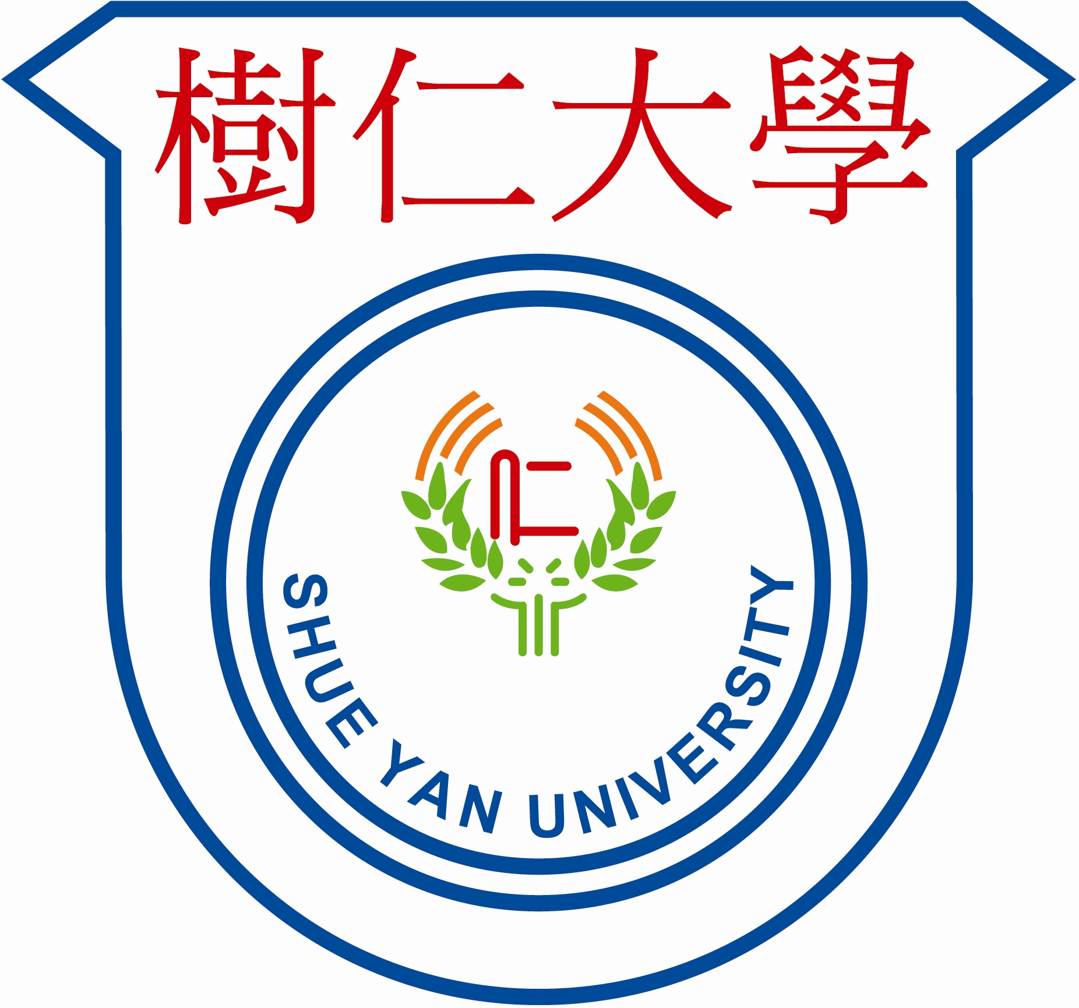
MASTER OF SOCIAL SCIENCES IN COUNSELLING PSYCHOLOGY

Transcript Request Form

Applicant should complete PART A and send it to your appropriate officer of institution from which the transcript is requested.

PART A Personal information

Applicant’s Name: _____________________________________ (_________________)
(English) (Chinese)

Contact Phone: _____________________________________________________________

University/Institution Attended: _______________________________________________

Date of Attendance: From ______________________ to ___________________________

Date of Award: _____________________________________________________________

PART B: Programme applied for admission at HKSYU

Master of Social Sciences in Counselling Psychology programme
Department of Counselling and Psychology
Hong Kong Shue Yan University
10 Wai Tsui Crescent, Braemar Hill,
North Point, Hong Kong

Part C: To the officer responsible for issuing transcripts

The above applicant has applied for admission to Master of Social Sciences in Counselling Psychology (2023-24) at Hong Kong Shue Yan University. Please send an official transcript together with this form to the above-mentioned address (PART B)

